**Lead Compensator**

**Topics Covered**

• Lead Compensator Design.

• Bode plots.

**Prerequisites**

• QUBE-Servo 2 Integration Lab.

• PD Control Lab.

**1 Background**

PID control uses integration and derivative operations to design a compensator such that the overall system response follows a desired trajectory. More generally, the design of a controller for a system can be regarded as a filter design problem. In this context, a PI controller is a *low-pass filter*, and because it introduces a negative phase over some frequency range, therefore it is also called a **phase lag controller**. Contrary, a PD controller is a *high-pass filter* that introduces a positive phase and is also referred to as a **phase lead controller**.

The generic transfer function of a simple lead or lag compensator can be expressed as

*s* + *z*

1 + *αT s*

*Clead,lag* (*s*) = *K*1 *s* + *p* = *Kc* 1 + *T s* (1.1)

which is a low-pass or phase lag controller for *α <* 1 (or *p < z*), and a high-pass or phase lead controller for *α >* 1

(or *p > z*).

The proportional gain of the lead compensator is used to attain a certain crossover frequency. In general, increasing the gain, and respectively the crossover frequency, essentially increases the bandwidth of the system, thus decreasing the system’s peak time (speeding up the response). A gain of *Kc >* 1 decreases the system’s phase margin and, if *Kc* is chosen too large, will lead to large overshoots in the system response. For design purposes, *Kc* is often chosen such that it increases the bandwidth of the system to about half the desired bandwidth. The lead compensator will add additional gain such that the combination of *Kc* and lead compensator result in the desired system bandwidth.

Even though lag compensators work well in theory, they often struggle with the saturation limits of actual hardware, and may not be able to achieve a zero steady-state error specification. In this lab, we will design a lead compensator in series with an integrator as in Figure 1.1 to achieve zero steady-state error. The resulting controller has the form

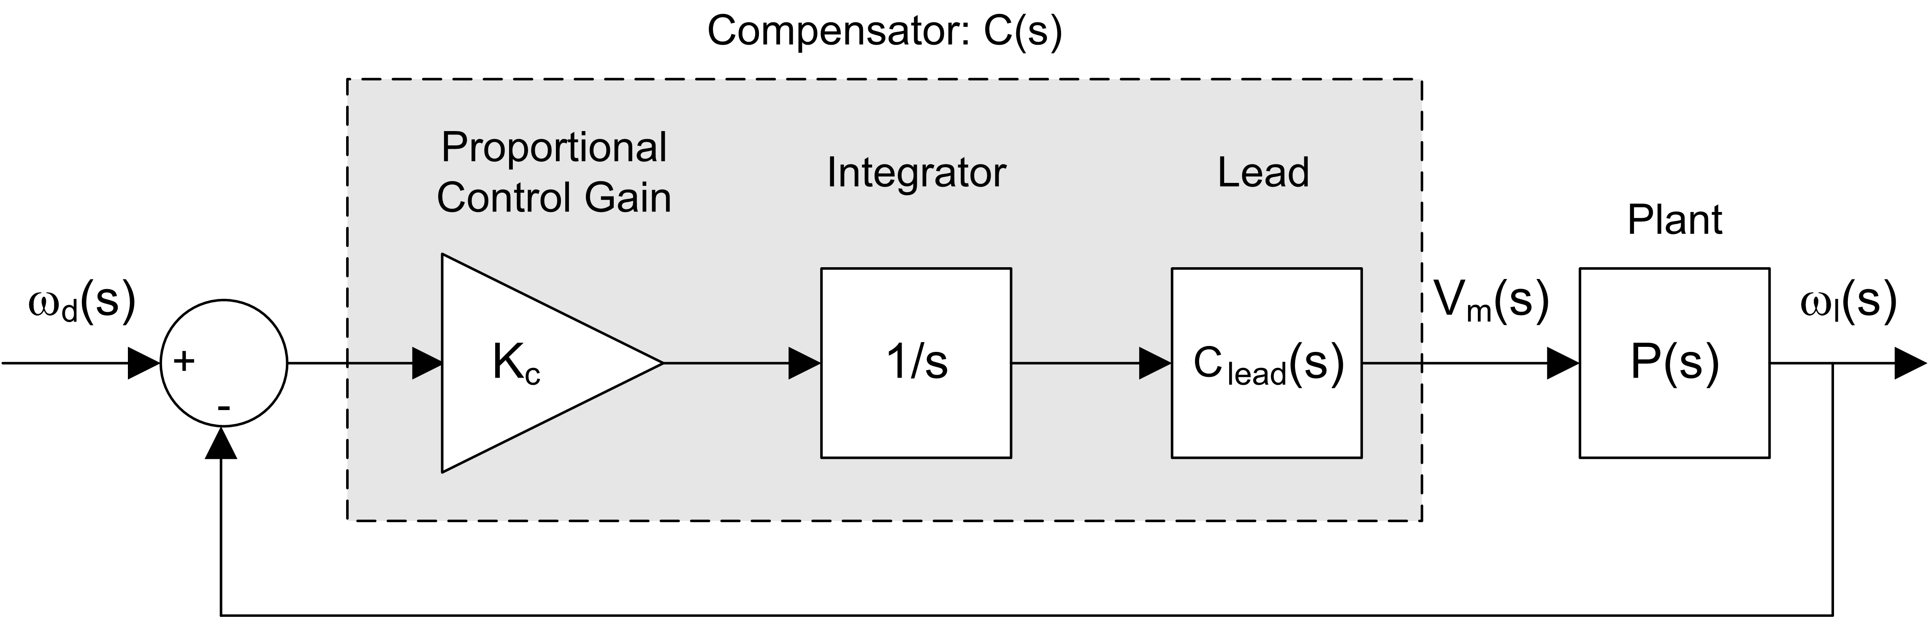

Figure 1.1: Closed-loop speed control with lead compensator

1 + *αT s*

*C* (*s*) = *Kc* (1 + *T s*)*s .* (1.2)

**1.1 Lead compensator design procedure**

The two main design parameters for a lead compensator are the desired phase margin and the desired crossover frequency. The phase margin mainly affects the shape of the response, and a higher phase margin implies a more stable response with less overshoot. As a rule of thumb, the overshoot *P O* will not go beyond 5 % for a phase margin of at least 75 deg.

The crossover frequency is defined as the frequency where the gain of the system is 1 (or 0 dB in a Bode plot). This parameter mainly affects the speed of the response and a larger *ωm* implies a decrease in the peak time. As a rule of thumb, the peak time *tp* will not be more than 0*.*05 s with a crossover frequency of at least 75 rad.

The design process for a lead compensator can be summarized as follows:

1. Generate the Bode plot of the open-loop uncompensated system.

2. The lead compensator itself will add some gain to the closed-loop system response. To make sure that the bandwidth requirement of the design can be met, a proportional gain *Kc* needs to be added such that the open-loop crossover frequency is about a factor of two below the desired system bandwidth.

3. Determine the necessary additional phase lead *ϕm* for the plant with open-loop gain *Kc* . To do so, compute

*ϕm* = *P Mdes − P Mmeas* + 5*,* (1.3)

i.e. add 5 degrees to the desired phase margin and subtract the open-loop measured phase margin.

4. Compute *α*. To attain the maximum phase *ϕm* at the frequency *ωm* as shown in Figure 1.2, the compensator is required to add 20 log10 (*α*) of gain. Here, *ωm* is the geometric mean of the two corner frequencies from the zero and pole of the lead compensator, respectively, i.e.

Solving for *ωm* reveals

1 (

log10 (*ωm* ) = 2

( 1

log10 *αT*

1

)

*−* log10

( 1 ))

*T*

*.* (1.4)

*ωm* = *√αT .* (1.5)

The proportional gain of the lead compensator is used to attain a certain crossover frequency. In general, increasing the gain, and respectively the crossover frequency, essentially increases the bandwidth of the system, thus decreasing the system’s peak time (speeding up the response). A gain of *Kc >* 1 decreases the system’s phase margin and, if *Kc* is chosen too large, will lead to large overshoots in the system response.

The lead compensator is used to dampen the overshoot and increase the overall stability of the system by increasing the phase margin. The frequency response of the lead compensator in (Equation 1.1) is given by substituting *s* = *jω* as

*Clead* (*jω*) =

with the corresponding magnitude and phase

1 + *jωαT*

*,* (1.6)

1 + *jωT*

*|Clead* (*jω*)*|* =

√ 1 + *ω*2 *α*2 *T* 2

1 + *ω*2 *T* 2 *,*

(1.7)

*ϕm* = arctan (*ωαT* ) *−* arctan (*ωT* )*.*

Using the trigonometric identity

on Equation 1.7 yields

tan (*α β*) = tan (*α*) + tan (*β*)

*−*

1 + tan (*α*) tan (*β*)

tan (*ϕ* (*jω*)) = *ωαT − ωT .* (1.8)

*m* 1 + (*ωαT* )(*ωT* )

Noting

and using Equation 1.5, one can find

tan (*α*) = sin (*α*) *,*

*±*

√

2

1 *−* sin (*α*)

sin (*ϕ* ) = *α −* 1 *.* (1.9)

*m α* + 1

Thus, if *ϕm* is known, *α* can be determined by solving

*α* = 1 + sin (*ϕm* )

1 *−* sin (*ϕm* )

*.* (1.10)

5. Determine the value of *T* using Equation 1.5. To do so, place the corner frequencies of the lead compensator such that *ϕm* is located at *ωm* , i.e. the new gain crossover frequency (the geometric mean of 1/*αT* and

1/*T* ) where the compensator has a gain of 10 dB. By design, *ωm* is the frequency at which the system

with compensator has 0 dB gain. Therefore, *ωm* has to be placed at the frequency where the magnitude

of the uncompensated system is *G*(*jω*) = *−*10 log10 *α* dB. *ωm* is then obtained by finding the corresponding frequency in the uncompensated Bode plot.

6. Determine the pole and zero of the lead compensator.

7. Check whether or not the compensator fulfills the design requirements. To do so, draw the Bode plot of the compensated system and check the resulting phase margin and check whether or not the system response meet the desired characteristics. Repeat the design steps for a different *ϕm* if necessary.

A typical Bode plot of a lead compensator is shown in Figure 1.2.

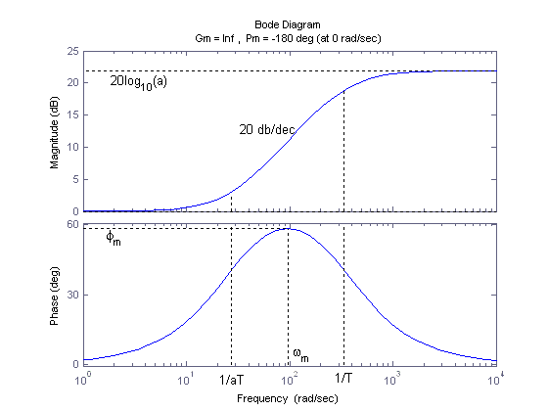

Figure 1.2: Bode plot of a typical lead compensator

**2 In-Lab Exercises**

In this lab, you will design a lead compensator for the speed control of the QUBE-Servo 2. Recall that the input voltage to output speed transfer function for the QUBE-Servo 2 is given by

*P* (*s*) =

*K*

*τ s* + 1

*.* (2.1)

As stated in the background section, we want to design a controller that is in series with an integrator to guarantee zero steady-state. For the design purpose of the lead compensator, we assume that the integrator is part of the plant model, i.e.

1

*Pi* (*s*) = *P* (*s*) *s .* (2.2)

The control design should fulfill the following design requirements for steady-state error (*ess* ), peak time (*tp* ), percentage overshoot (*P O*), phase margin (*P M* ) and system bandwidth (*ωm* ):

*ess* = 0*,*

*tp* = 0*.*05 s*, P O ≤* 5 %*,*

*P M ≥* 75 deg*,*

*ωm ≥* 75*.*0 rad/s*.*

(2.3)

1. Find the magnitude of the frequency response of the system transfer function (Equation 2.2) that is in series with an integrator (*|Pi* (*s*)*|*) in terms of the frequency *ω*.

2. The system has a gain of 1 (or 0 dB) at the crossover frequency *ωg* . Find an expression for the crossover frequency in terms of the model parameters *K* and *τ* for *Pi* (*s*). Use this expression to determine the crossover frequency for the QUBE-Servo 2 using *K* = 21*.*9 and *τ* = 0*.*15.

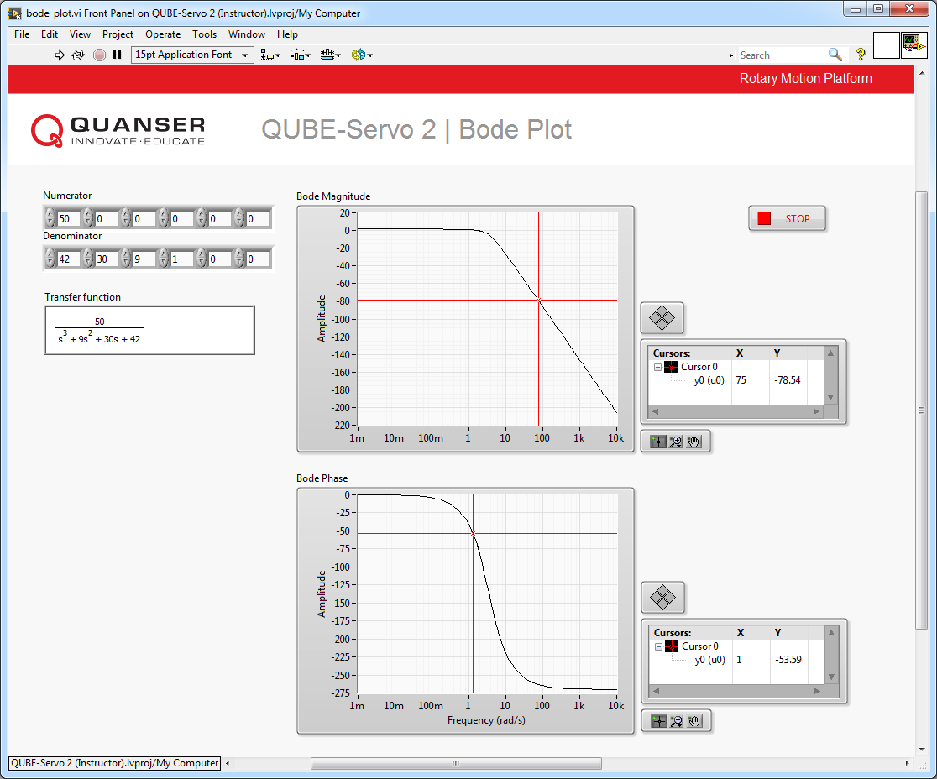

Figure 2.1: LabVIEW VI to generate a Bode plot.

3. Generate the Bode plot of *Pi* (*s*) using bode_plot.vi shown in Figure 2.1. To open the VI, expand the Windows target as well as the *Bode Plot* virtual folder. Using *K* = 21*.*9 and *τ* = 0*.*15 (or using the values you determined after performing the Bump Test Modeling laboratory experiment), enter appropriate values in the Numerator and Denominator numeric controls to generate the desired transfer function. Compare your derived frequency from the previous step to that obtained using the cursor palette in the Bode Magnitude and Bode Phase XY Graphs.

4. Find the proportional gain *Kc* that is necessary such that *Kc Pi* (*s*) has a crossover frequency of 35 rad/s (about half the desired closed-loop bandwidth).

5. Determine the necessary phase lead *ϕm* that the lead compensator needs to add for the system *Kc Pi* (*s*).

6. Compute *α*.

7. Determine *ωm* .

8. Does *ωm* meet the design requirement of *ωm ≥* 75 rad/s? Comment on what you could do to ensure you meet this requirement.

9. Determine the transfer function of the lead compensator. Start by evaluating *T* .

10. Determine the pole and zero location of the lead compensator. Generate the Bode plot of your lead compensator and verify that you have the desired phase margin at the desired frequency.

11. Validate your result by obtaining the closed-loop bode plot with proportional gain *Kc* and lead compensator

*CL* (*s*). Do you have the desired phase margin at the desired frequency?

12. Open QUBE-Servo 2 Lead.vi and implement your lead compensator *CL* (*s*) with proportional gain *Kc* = 8*.*21.

Run your controller. Does the system response match the desired characteristics? Try varying the value of

*Kc* and see if you can improve the overall system response.

© 2017 Quanser Inc., All rights reserved.

Quanser Inc.

119 Spy Court Markham, Ontario L3R 5H6

Canada [info@quanser.com](mailto:info@quanser.com) Phone: 1-905-940-3575

Fax: 1-905-940-3576

Printed in Markham, Ontario.

For more information on the solutions Quanser Inc. offers, please visit the web site at:

[http://www.quanser.com](http://www.quanser.com/)

This document and the software described in it are provided subject to a license agreement. Neither the software nor this document may be used or copied except as specified under the terms of that license agreement. Quanser Inc. grants the following rights: a) The right to reproduce the work, to incorporate the work into one or more collections, and to reproduce the work as incorporated in the collections, b) to create and reproduce adaptations provided reasonable steps are taken to clearly identify the changes that were made to the original work, c) to distribute and publically perform the work including as incorporated in collections, and d) to distribute and publicly perform adaptations. The above rights may be exercised in all media and formats whether now known or hereafter devised. These rights are granted subject to and limited by the following restrictions: a) You may not exercise any of the rights granted to You in above in any manner that is primarily intended for or directed toward commercial advantage or private monetary compensation, and b) You must keep intact all copyright notices for the Work and provide the name Quanser Inc. for attribution. These restrictions may not be waved without express prior written permission of Quanser Inc.